EXECUTIVE SUMMARY

Predicting Student Housing Demand at HKU: Planning for Growth
Group Members
VU Tuong Vy
3036385664

The Problem
As HKU's student enrollment grows, the university faces an urgent planning challenge: dormitory capacity is fixed, but demand is increasing. Without knowing which students will choose dormitory housing, HKU cannot prepare alternative housing solutions. Therefore, we conduct this study to answer a critical question: Can we predict which students will choose dormitory housing, and what drives their decisions?
What We Did
First, we surveyed 162 HKU students, asking about their housing choices and what factors influenced them: personal background (year, status), finances (scholarship, housing budget), and priorities (price, privacy, commute time, facilities quality, study environment, social life, flexibility with rules, sustainability features, and willingness to pay a green premium). Then, we built a classification tree to explain the key factors driving predictions visually, and finally enhanced the prediction accuracy of the tree by random forest. The models are trained on 75% of the data and tested against the remaining 25%.

What We Found
Both models (single Classification Tree and Random Forest) predict undergrad housing preference at 70-75% accuracy - clearly better than a coin flip, though modest given our sample size. CART reaches 75% accuracy (AUC 0.70), while Random Forest reaches 70% accuracy (AUC 0.73); the two models trade off which group they identify better, with CART more reliable at flagging dorm residents and Random Forest more reliable at flagging off-campus students. Housing budget turned out to be the first decision point, as students already paying (or willing to pay) HK$4,000 or more per month skew heavily toward living off campus. Among students with lower housing budgets, year of study, commute time, study environment, and facilities quality further separate dorm residents from off-campus students. Sustainability features and willingness to pay a green premium were measured for the first time in this round of data collection, but did not emerge as meaningful predictors in either model - environmental preferences do not yet appear to be a decisive factor in HKU students' housing choice.
How HKU will benefit from our models
Our models serve as a useful starting point for capturing student housing preferences, as they allow HKU to immediately forecast dormitory demand using the current database. If the predicted demand exceeds campus housing capacity too much, the school can seek partnering with more external housing agencies and securing exclusive deals for students, which will relieve stress on both dormitory systems and students in the next semester.

Our Reccomendations
Looking ahead, the model can be incorporated into the current system, reducing the housing crisis for students and allowing the university to monitor growth effectively.

Section 1: Introduction, Problem Description, and Significance of the Problem. (1.5 page) (DPhuong)
- Intro (Cedars, students accomodation needs…)
The University of Hong Kong (HKU) is currently one of the world's highest-ranked universities, attracting a large number of undergraduate students, who we will focus on in this report. In the last academic year, HKU reported a total number of 19,038 undergraduate students, of whom about 29.6% are international students (The University of Hong Kong, 2025). This number is expected to rise significantly to a 50% non-local student ratio (The Standard, 2025), leading to a growing demand for housing. Due to the high housing prices in Hong Kong, it is difficult to find affordable apartments or studios that offer comfortable space and enough facilities; therefore, students often prefer staying in dormitories since they are convenient and fully equipped. Currently, HKU’s CEDARS (Centre of Development and Resources for Students) provides two main kinds of dormitory, residential halls (e.g., Swire Hall, Ricci Hall, ...) and residential colleges, including Jockey Club Student Village III (JCSV III) and JCSV IV. Besides, HKU also offers some university-partnered choices to help students find accommodation more easily. Despite those diverse housing choices, there are not enough vacancies for all students, since the dormitories are for both undergraduate and postgraduate students. As a result, a high percentage of students have to rent outside the campus, facing high costs and inconvenience.
- Problem description
CEDARS is facing a significant problem of a lack of insight into the factors that affect students’ housing decisions. This makes the process of choosing and assigning students to dormitories much more challenging in the trend of demand further exceeding supply, which may lead to misallocation of dormitory slots. For instance, CEDARS may prioritize early applicants for dormitories over those with urgent needs such as financial difficulties, and local students are prioritized over international students with little local family support. This results in increasing worries for students, especially international students who may find it harder to settle down in a new country.
To solve this problem, our report will answer two main research questions using the survey data that we will analyze in R. The first question is to find what the factors that affect mostly undergraduate students’ decisions in choosing whether to stay in dorms are. Secondly, we will address the question of whether CEDARS can predict students’ housing choices with high accuracy.
- Significance(for Cedar, for students)
By addressing this major problem, CEDARS can improve its transparency in the decision-making process of planning and allocating students to residential dormitories, ensuring fairness and priorities for those with the greatest needs. Additionally, analyzing and predicting the important factors impacting housing choices allow HKU to reasonably invest in renovation and development for the dorms, satisfying students’ expectations of features such as facilities or dorm communities. This helps to improve students’ well-being and therefore attracts new students and maintains old students’ retention.

Section 2: Data description. (1 page) (Treng)
- Information needed
- Information collect method(why?how?)
- Interpret the info (types, levels, meaning)

Section 3: Data Analytics Methods, Analysis, and Results (Long +Nhoong)
- Reasons for choosing CART
In this study, we implemented the use of CART in HKU student’s housing choices for three following reasons. First, our goal is to predict a binary outcome (e.g., dorm vs non-dorm) with a mix input of numerical ratings (price, privacy,..) and categorical variables (status, year, scholarship,..). To this end, CART can perfectly facilitate the problem by its strength in classification and ability to handle both mentioned types without strong assumptions (no need for normality, equal variance). Second, the combination of resulting if-then rules and visual tree can demonstrate a more transparent and simple correlation among factors to influence the outcomes. This, in turn, supports CEDARS staff/ marketing teams in decision making with actionable insights such as where to improve facilities, which student segments to target. Finally, as the effect of the “price” variable is non-linear, depending on whether students have scholarship, status (local vs international), year, CART can automatically identify these interactions via splits instead of manually specifying, improving the efficiency for the operation.
- CART Model building process and Interpretation
  - Steps to build
Overall, this process encompasses major 4 steps, commencing at data preparation and finishing at prediction and evaluation on the data set:
- Step 1 (Data preparation): The original data set includes 10 observations: a target variable (whether students live in the dorm) and several predictors (status, year of study, scholarship,..) and perception ratings (privacy priority, affordability, distance,...). Then we cleaned the data by formatting the variable to factor, and removing the missing or irrelevant values.
- Step 2 (Train-test split): We randomly split the cleaned dataset into a training set and a test set to evaluate out‑of‑sample performance. The training set was used to build and tune the CART model, while the test set was held out and only used at the end to assess how well the model generalizes to new observations
- Step 3 (Train and tune CART): We fitted a classification tree on the training set, specifying the target and predictor variables and method = "class". To control tree complexity and avoid overfitting, we tuned the complexity parameter (cp = 0.03) using the cross-validation. This procedure selects the tree size that best balances model fit and simplicity, rather than always choosing the deepest possible tree
- Step 4 (Evaluation): After major steps, we finalized the trained CART model to obtain prediction. We compared those predictions by conducting a confusion matrix and summarized the overall accuracy AUC (Area under the ROC curve). These metrics indicate how well our model classifies the observations and how effectively it distinguishes between two classes with different thresholds.
  - CART Model Interpretation
The interpretation of our model is determined by its tree structure (Figure 1) and its performance on unseen data. The final pruned tree splits on six variables: monthly housing budget, year of study, commute time, study environment, faculty, and facilities. Each internal node represents a decision point for the corresponding variable; terminal leaves identify dormitory or non-dormitory outcomes based on the decisions made at the nodes. To be more specific, from the top of the tree structure, students already paying (or willing to pay) HK$4,000 or more per month are predicted not to live in the dorm, especially if they are in Year 4 or above. Among students in this higher-budget bracket who are in Year 1-3, a longer commute further predicts off-campus living. For students in the lower housing-budget bracket (under HK$4,000), a high study-environment rating leads to a further split on faculty and facilities: within Arts, Law, Medicine, and Science most are predicted off-campus, while in the remaining faculties, rating facilities highly predicts dorm living; students in this lower-budget bracket who rate study environment as less important are predicted to live in the dorm regardless of faculty. Overall, the tree suggests that housing budget is the single strongest split, with year of study, commute time, and facilities quality refining the prediction within each budget group. Sustainability features and willingness to pay a green premium were included as candidate predictors but were not selected at any split in the tree, indicating they did not help separate dorm from non-dorm students in this sample.
Furthermore, test accuracy (75%) from the confusion matrix (Figure 2) demonstrates that the tree classifies students’ dormitory status well above chance, with a sensitivity of 0.70 for correctly identifying off-campus students and a specificity of 0.80 for correctly identifying dorm residents. The ROC curve gave an AUC of 0.70, indicating a reasonable but not strong ability to differentiate dormitory versus non-dormitory residents at various probability thresholds. To conclude, the CART model provides interpretive characteristics regarding the decision-making process that can be used to inform, though not conclusively determine, dormitory choice reasons.
- Random Forest Model and Evaluation
  - Random Forest Model
To further identify the most significant predictors and check whether an ensemble method could improve on the single tree, we implement the Random Forest model with 500 trees and a minimum node size of 25, using the same seed and the "randomForest" package, this time also including the two newly-collected sustainability variables. For out-of-sample accuracy, we apply the model to make predictions on unseen data, yielding a confusion matrix with sensitivity of 0.75 and specificity of 0.65. Compared to CART, Random Forest is somewhat more accurate at correctly flagging off-campus students (sensitivity 0.75 vs. 0.70) but noticeably less accurate at correctly flagging dorm residents (specificity 0.65 vs. 0.80). This trade-off brings Random Forest's overall accuracy to 70%, slightly below CART's 75%, showing that the ensemble does not uniformly outperform the single tree on this dataset. Plotting the ROC curve in R shows a modest improvement over CART, with an AUC of 0.73 compared to CART's 0.70. This is a real but small gain — not the dramatic separation a much higher AUC would suggest — and is consistent with a dataset this size (160 respondents) having only a limited, noisy signal to work with. (Figure 3)
While a single CART tree offers a clear visual map of key splits, highlighting housing budget, year, commute, and facilities as critical segments, the Random Forest demands a more aggregated view through mean decrease in Gini impurity. This metric indicates the average node impurity that each variable reduces across all trees, increasing the homogeneity of each node and thereby reducing prediction error. Plotting this in R, year of study, faculty, and housing budget show the highest importance scores, followed by privacy and commute time. Study environment and price rank in the middle of the pack, with facilities and social factors somewhat lower. Notably, our two newly-collected sustainability variables — sustainability features and willingness to pay a green premium — rank near the bottom of the list, just above scholarship and student status, which were the least important predictors overall. This indicates that, while environmental preferences were worth measuring, they are not yet among the attributes that most strongly separate dorm residents from off-campus students at HKU. By ranking the variables according to their mean decrease in Gini, Random Forest provides a straightforward view of which factors carry the most weight in students' choice of living place, even where the overall predictive power remains modest. (Figure 4)
  - Evaluation and enhancement
Though CART provides an intuitive tree with detailed steps to the final decision, Random Forest is generally expected to generate a more robust, less overfit prediction by analyzing several trees with randomly resampled data and using majority "votes." In our case, however, that expectation only partly held: Random Forest's AUC (0.73) modestly outperforms CART's (0.70), but its overall accuracy (70%) is actually a few points lower than CART's (75%), and it is noticeably weaker at correctly identifying dorm residents specifically (specificity 0.65 vs. CART's 0.80). We therefore treat the two models as complementary rather than declaring one outright better: CART remains the more interpretable choice for CEDARS staff who need a clear step-by-step decision path, while Random Forest's variable importance ranking offers a more aggregated, and likely more stable, view of which factors matter most overall. Several existing limitations still need to be improved regardless of which model is used. Firstly, our limited sample size (160 respondents) is likely to make accuracy estimates unstable from one train/test split to the next, asking for a more extended sample and cross-validation for a better-fit model. Secondly, we should consider integrating the CART tree to have a clear vision of the step-to-step prediction process alongside using highly precise forecasts of Random Forest for deeper, practical insights into student accommodation decisions. Moreover, we merely obtain a personal view of students without considering the objective factors such as income status or legal status, which may drive their decisions dramatically. Lastly, individual preferences may fluctuate over time and across generations, leading to an easily out-dated, overgeneralized and stereotypical model. Therefore, it is essential for us to continuously update the data alongside incorporating both internal and external factors into the model building to ensure the sustainability and reliability of the model.

CONCLUSION
Our CART and Random Forest models, which yield accuracies of 75% and 70% and AUCs of 0.70 and 0.73 respectively, can provide directionally useful, though not highly precise, predictions with regards to the housing choice of students. These results should not be used as absolute predictions, but as strategic guidance only. Housing budget, year of study, and commute time stand out as the strongest available predictors, while the newly-collected sustainability preferences do not yet meaningfully separate dorm from off-campus students. It is imperative that additional nuanced data, and a larger sample, be incorporated into the model in order to construct a more holistic prediction capability, with the goal of creating a tailored housing plan for the diverse and evolving HKU student community in mind.
Recommendations
CEDARS Life Section should establish a ‘Housing Demand Forecasting’ team which focuses on the shift from reactive planning to data-driven strategizing.
- Applying Predictive Model and Partnerships: Annually run the model every July; if predicted demand surpasses capacity by 20%, immediately enter exclusive housing agreements with accommodation providers in the vicinity in order to secure housing for at least 25% of the overflow.
- Expand Research and Data Collection: conduct longitudinal follow-up surveys and analyze the distinctive needs of local and international students in order to keep the model up-to-date and fit the shift in the needs of students. Continue tracking sustainability preferences (energy efficiency, recycling facilities, willingness to pay a green premium) in future survey rounds — while these did not emerge as leading drivers in this sample, a larger, repeated sample would show whether that changes as environmental features gain visibility in student housing more broadly.

References
The Standard. (2025, October 9). HKU aims for 50pc non-local student ratio next year. https://www.thestandard.com.hk/hong-kong-news/article/313719/HKU-aims-for-50pc-non-local-student-ratio-next-year
The University of Hong Kong. (2025). Student Profiles. Quick Stats. https://www.cpao.hku.hk/qstats/student-profiles

Appendix
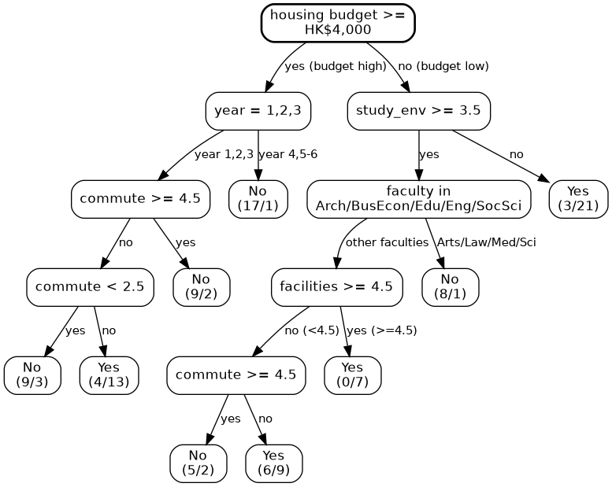
Figure 1. CART tree

 | No | Yes
No | 14 | 4
Yes | 6 | 16
Figure 2. CART’s confusion matrix table

Metrics | CART | Random Forest
Sensitivity | 0.70 | 0.75
Specificity | 0.80 | 0.65
Overall Accuracy | 0.75 | 0.70
AUC | 0.70 | 0.73
Figure 3. CART vs Random Forest
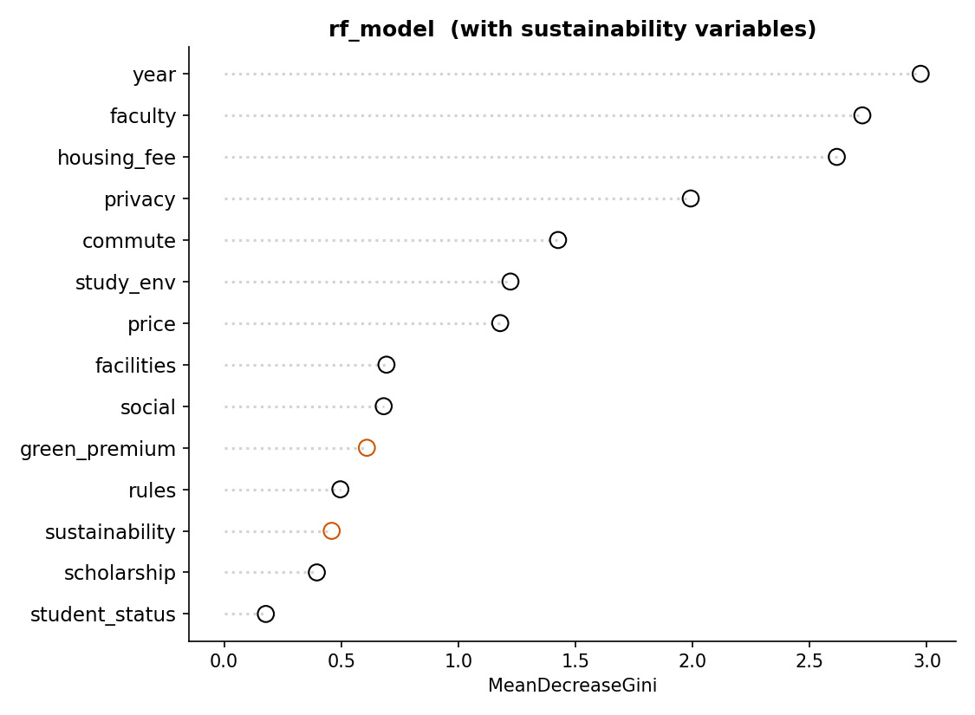
Figure 4. Variable importance plot

